**MySQL Community Server Database**

MySQL is the most popular open-source database available. Now owned by Oracle, but still community supported, it is an enterprise-level database behind major businesses such as Verizon Wireless, Zappos, Facebook, LinkedIn, Twitter, craigslist, Walmart and Sears. It is available in several versions from Standard to Enterprise (with prices starting from $2,000 to $10,000) and the community edition, which is still available at no charge. This is the version we’ll be using.

**For MS Windows users**, there is an all-in-one installation of MySQL Community Server (172 MB), downloadable at :  
[**http://dev.mysql.com/downloads/installer/**](http://dev.mysql.com/downloads/installer/)

It includes :  
- MySQL Server  
- All of our support connectors  
- Workbench and sample models  
- MySQL Notifier  
- MySQL for Excel  
- MySQL for Visual Studio  
- Sample databases  
- Documentation

**For users of Mac OSX or Linux installations**, or for Windows users who don’t want to install everything available,   
use the following site for the MySQLCommunity Server. Note – MySQL may already be installed as a base package in Mac OSX :

[**http://dev.mysql.com/downloads/mysql/**](http://dev.mysql.com/downloads/mysql/)

In addition to the database server, we’ll be using the MySQL Workbench as a good User Interface rather than the command-line interface provided by the bare-bones MySQL Server. If you’re a Windows user and have downloaded the all-in-one installer, you won’t need to install Workbench. It’s already included in the download.

**MySQL Workbench** provides DBAs and developers an integrated tools environment for:  
- Database Design & Modeling   
- SQL Development   
- Database Administration

The MySQL Workbench for all platforms is downloadable at:

[**http://dev.mysql.com/downloads/workbench/5.2.html**](http://dev.mysql.com/downloads/workbench/5.2.html)

**Installation Guides for MySQL Community Edition** for all OS’s are found here:

[**http://dev.mysql.com/doc/refman/5.6/en/installing.html**](http://dev.mysql.com/doc/refman/5.6/en/installing.html)

They’re very detailed and thorough. Be sure to record your user name and password.

**Installation Guides for MySQL Workbench**  for all OS’s are found here:

[**http://dev.mysql.com/doc/workbench/en/wb-installing.html**](http://dev.mysql.com/doc/workbench/en/wb-installing.html)

**Sample Database (sakila)**

We’ll be using the **sakila** database for SQL training (a complete video store / movie database). If you’re a Windows user and have downloaded the all-in-one installer, you won’t need to install the sample databases. They’re already included in the download. For everybody else, the sample downloads are available at:

[**http://dev.mysql.com/doc/index-other.html**](http://dev.mysql.com/doc/index-other.html)

Download the **sakila** database and its setup guide.

**Installation Guide for the sakila sample database**  is found here:

[**http://dev.mysql.com/doc/sakila/en/index.html**](http://dev.mysql.com/doc/sakila/en/index.html)

(see item **4. Installation** for details <http://dev.mysql.com/doc/sakila/en/sakila-installation.html> )

**MySQL References**

The classic MySQL reference and tutorial is available as a free pdf download at:

<http://www.e-reading-lib.org/bookreader.php/142091/MySQL._4Ed.pdf>

All MySQL documentation can be found on the MySQL website at :

<http://dev.mysql.com/doc/>

**MySQL Workbench**

The easiest way (in open-source, no-cost terms) to interact with MySQL is with MySQL Workbench.

The first section of the MySQL Workbench is:

- **SQL Development** : Connect to existing databases, Create New Databases, Create and Edit Tables, Queries, Views, Stored Procedures, and Insert, Delete, or Modify Data in any table.

|  |  |
| --- | --- |
|  | The first entry (mysql11.my_ISP.com) shows a connection to a data source provided by a user’s ISP (this is not addressed in this session) |

The local workspace is “**localhost**” – double-clicking on this brings you to the SQL Editor for the databases installed on your local drive:

|  |  |
| --- | --- |
|  | The SQL Editor shows the databases (Schemas) available in “localhost”, your local drive.  Shown here are 3 installed databases: - sakila - test - world |

Opening any of them shows the objects contained in that database:

|  |  |
| --- | --- |
|  | Opening the Tables in the sakila database lists Tables, Views, and Routines available in that database.  Drilling down on Tables lists all of the tables in that database.  Drilling down on one of the tables (actor) gives the choice of Columns (fields) in the database, Indexes, Foreign Keys, and Triggers.  Clicking the table name shows the column names and properties in the **Information** window beneath.  The bold underlined field actor_id shows it is a primary key.  The bold field last_name shows it is indexed. |

Right-clicking the table name and selecting “**Alter Table…**” brings up the design specs for that table, with tabs for editing Columns, Indexes, Foreign Keys, etc.

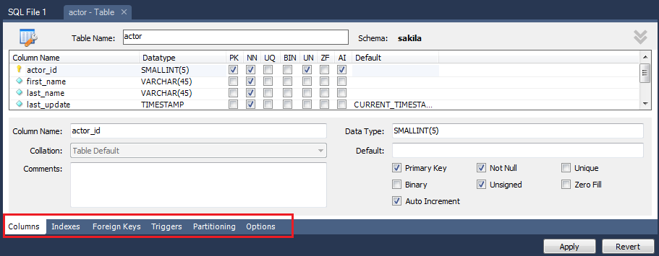

To view the entire “**CREATE TABLE**” statement in SQL, right click the table, then make the selections shown below:  
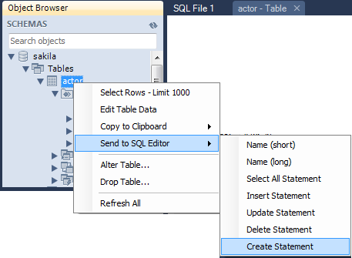

Below is the **SQL window** that you use for SQL development:

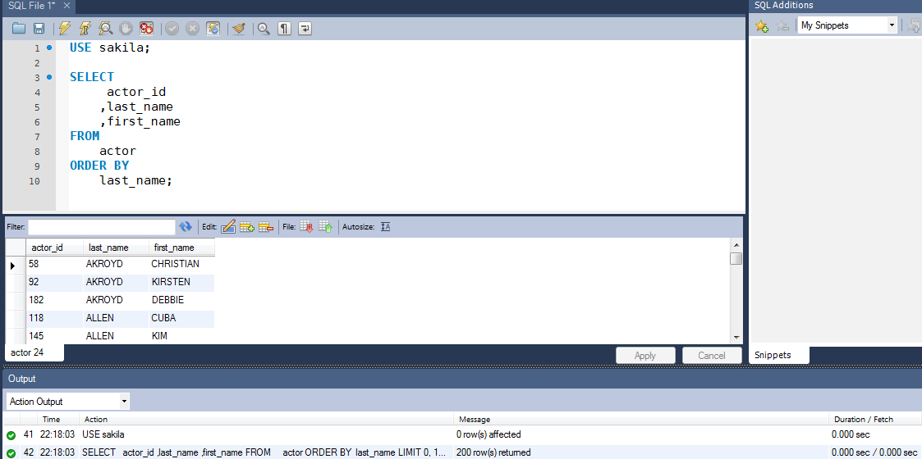

The icons in the **SQL Editor tab** are shown below:

|  |  |
| --- | --- |
|  | Most commonly used:  opens a new SQL tab  opens a previously saved SQL file  create a new database (schema)  create a new table in the selected database  create a new view in the selected database |

In the **Query window**, these options are available:

|  |  |
| --- | --- |
|  | Most commonly used:  open a previously saved SQL file  save the current SQL Query file  run the selected SQL, or the entire SQL Query window  run the SQL query under the cursor |

In the **Query Output window**, these options are available:

|  |  |
| --- | --- |
|  | edit the selected row  add a new row  delete the current row  download the current recordset  import records from an external file |

In the Action Output Window at the bottom of the screen (see the screenshot of the SQL window on the previous page), the SQL statements that were executed (successfully or unsuccessfully) are shown, with the number of rows effected, and the time to execute the query.

Note that MySQL limits the output to the Query Output Window to 1000 rows.

If there are more than 1000 rows, there will be an option to download the 1000 rows that are displayed or the entire recordset to an external file.

The second section of the MySQL Workbench is the **Data Modeling** Section:

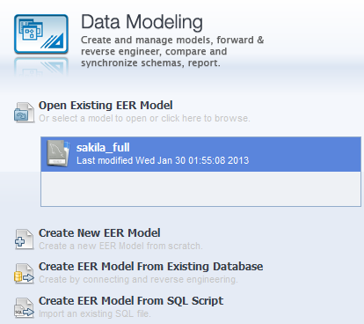

The existing ER Model is shown here. Double-clicking it will open the ER diagram.

You also have the ability to :  
 - Create a new EER Model from scratch  
 - Create an EER Model from an existing database (reverse engineer the model)  
 - Create an EER Model by reverse-engineering the SQL script of the database schema

The third section of the MySQL Workbench is the **Server Administration** section:

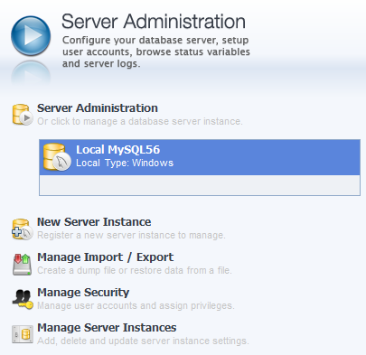

This section has database administration tasks (adding users, data backups, security, etc)

This will not be covered in this session.